SESSION-2
TASK-1
Create a Bugzilla account using your college or personal email, then log in and take a screenshot of your Bugzilla dashboard after successful login.
ANSWER:
Step 1: Open the Bugzilla Website
- Open Google Chrome or any other web browser.
- Visit the official Bugzilla website
- The Bugzilla homepage will appear on the screen.
Step 2: Create a Bugzilla Account
- Click on the Log In option.
- Select the option to create a new account.
- Enter your college or personal email address.
- Follow the instructions to complete the registration.
- If email verification is required, open your email and verify your account.
Step 3: Log In to Bugzilla
- Return to the Bugzilla login page.
- Enter your registered email address and password.
- Click on Log In to access your account.
Step 4: View the Bugzilla Dashboard
- After logging in successfully, the Bugzilla dashboard or home page will appear.
- Explore the available options, such as searching for bugs, reporting a bug and viewing existing bug reports.
- Take a screenshot of your dashboard as proof of successful login.

Screenshot:
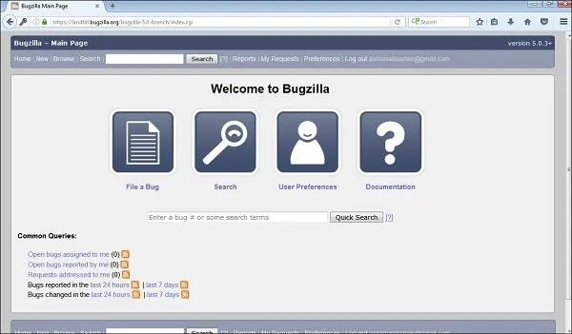
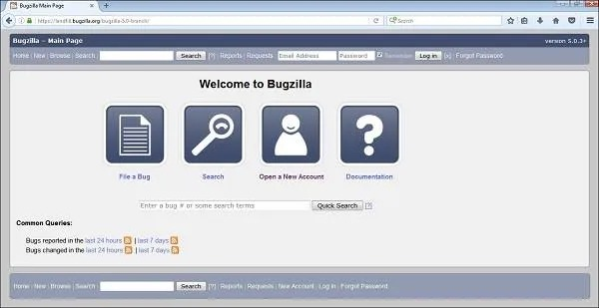

Conclusion
In this task, I learned how to create an account on Bugzilla and log in successfully. I also got familiar with the Bugzilla dashboard and its basic features. Bugzilla is useful for reporting, tracking and managing software defects, which helps testers and developers find and fix bugs more easily.

TASK-2
Pick any mobile app you use daily (such as Instagram, Zomato, or Paytm) and identify a real or imagined bug you have experienced — log this bug in Bugzilla with a clear summary, detailed steps to reproduce, expected vs actual result, and attach a screenshot or mock image showing the issue.
ANSWER:
1. Application Selected
- App Name: Instagram
- Platform: Android
- Bug Type: UI (User Interface) Bug
- Bug Title: Instagram Story Text Overlaps with the Post Buttons
- Bug Status: New (imagined bug for practice)
2. Bug Description
While using Instagram, imagine that I noticed a problem when adding a long text caption to a story. The text overlaps with the buttons at the bottom of the screen, making it difficult to read and use the story editing options.
3. Steps to Reproduce
- Open the Instagram application on an Android phone.
- Log in to your account.
- Tap on the + icon and select the Story option.
- Select a photo from the gallery.
- Tap the text option to add a caption.
- Enter a long caption that takes up multiple lines.
- Observe the text and the buttons at the bottom of the screen.
4. Expected Result
The text should be displayed properly within the story editing area without overlapping any buttons or options. All editing buttons should remain visible and usable.
5. Actual Result
The long text overlaps with the buttons at the bottom of the screen. This makes the interface difficult to use and some editing options may become hard to access.
6. Bug Severity and Priority
Field | Details
Severity | Minor
Priority | Medium
Environment | Android mobile
Bug Category | UI Bug
Status | New

TASK-3
Log two more defects in Bugzilla for different apps (for example, a payment failure in PhonePe or a wrong item added in Flipkart cart), making sure to select appropriate Severity and Priority for each defect and fill out the Module and Build/Version fields.
ANSWER:
Bug 1: Payment Failure in PhonePe
1. Application Details
Field | Details
Application | PhonePe
Platform | Android
Module | UPI Payments
Build/Version | 25.0.0 (sample version)
Bug Type | Functional Bug
Severity | Major
Priority | P1 – High
Status | NEW
2. Bug Summary
Payment fails in PhonePe, but the amount is deducted from the user's bank account.
3. Bug Description
While making a payment through PhonePe, imagine that the app displays a payment failed message even though the amount has been deducted from the bank account. This creates confusion for the user, who may not know whether the payment was successful.
4. Steps to Reproduce
- Open the PhonePe application.
- Log in to your account.
- Select a contact or enter a UPI ID.
- Enter a payment amount.
- Enter the UPI PIN and confirm the payment.
- Observe the payment status displayed on the screen.
5. Expected Result
The app should display the correct payment status. If the payment is successful, it should show a successful message and generate a transaction record.
6. Actual Result
The app displays a payment failed message even though the amount appears to have been deducted from the bank account.
7. Severity and Priority
- Severity (Major): This could affect the user's money and cause confusion about the transaction.
- Priority (High): The issue should be investigated promptly because it involves payment status and financial transactions.
Bug 2: Wrong Item Added to Cart in Flipkart
1. Application Details
Field | Details
Application | Flipkart
Platform | Android
Module | Shopping Cart
Build/Version | 10.0.0 (sample version)
Bug Type | Functional Bug
Severity | Minor
Priority | P2 – Medium
Status | NEW
2. Bug Summary
Wrong product is added to the cart after selecting a different item in Flipkart.
3. Bug Description
Imagine that while shopping on Flipkart, I select a particular product and click on the "Add to Cart" button. However, a different product appears in the cart instead of the selected one. This may cause confusion and lead to an incorrect order if the user does not notice the issue.
4. Steps to Reproduce
- Open the Flipkart application.
- Log in to your account.
- Search for a product, such as a blue T-shirt.
- Open the product details page.
- Select the required size and colour.
- Click on the "Add to Cart" button.
- Open the shopping cart and check the added product.
5. Expected Result
The selected product, including its correct size, colour, and quantity, should be added to the shopping cart.
6. Actual Result
A different product or an incorrect variation appears in the cart instead of the selected item.
7. Severity and Priority
- Severity (Minor): The issue affects the shopping experience but can usually be corrected by removing the wrong item and adding the correct one.
- Priority (Medium): The issue should be fixed in a planned update to prevent incorrect cart entries.
Conclusion
In this task, I prepared two additional bug reports for PhonePe and Flipkart. The first bug is related to a payment status failure, while the second bug is related to an incorrect item being added to the cart. I learned how to select suitable severity and priority levels and how to fill in the module and build/version fields. This activity helped me understand how defects are documented and reported in a structured way using Bugzilla.

TASK-4
Update the status of one of your logged defects in Bugzilla from 'New' to 'Assigned', then to 'Fixed', 'Retest', and finally 'Closed', adding a brief comment at each stage describing what happened.
Hint: Use the 'Add Comment' box in Bugzilla to note what action was taken at each step.
ANSWER:
1. Bug Details
Field | Details
Application | PhonePe
Bug Summary | Payment fails, but the amount is deducted from the bank account
Module | UPI Payments
Severity | Major
Priority | P1 – High
Initial Status | New
Final Status | Closed

2. Bug Life Cycle
- New
The bug has been reported and is waiting to be reviewed.
Comment:
The payment status issue has been identified and reported. The app shows payment failed even though the amount appears to have been deducted. The defect is submitted for review.

- Assigned
The bug has been reviewed and assigned to a developer for investigation.
Comment:
The reported defect has been reviewed and assigned to the development team. The developer will investigate the payment status issue and identify its cause.
- Fixed
The developer has made a correction to resolve the issue.
Comment:
The developer has implemented a fix to ensure that the payment status is displayed correctly. The updated build is ready for testing.
- Retest
The tester checks whether the fix works as expected.
Comment:
The defect has been retested on the updated build using the payment test scenario. The payment status is now displayed correctly, and the issue could not be reproduced during retesting.
- Closed
The fix has passed retesting, and the defect is considered resolved.
Comment:
Retesting was successful, and the expected payment status is displayed correctly. The defect is verified as resolved and is now closed.
3. Steps to Update the Bug Status in Bugzilla
- Log in to your Bugzilla account.
- Open the bug report that you created.
- Click on the Edit option or locate the status field.
- Change the status from New to Assigned and enter the relevant comment in the Add Comment box.
- Save the changes.
- Repeat the process to change the status to Fixed, Retest and finally Closed, adding the corresponding comment at each stage.
- Save each update and verify that the status and comments appear in the bug history.
Status tracking record
Status | Comment added
New | Defect reported
Assigned | Assigned for investigation
Fixed | Correction implemented
Retest | Fix tested successfully
Closed | Defect verified and resolved

Conclusion
In this task, I learned about the different stages of the bug life cycle in Bugzilla. I understood how a defect moves from New to Assigned, Fixed, Retest and Closed. I also learned the importance of adding comments at every stage to maintain a clear record of the actions taken. This process helps testers and developers track defects, verify fixes and ensure that reported issues are properly resolved.

TASK-5
Use Bugzilla's search and filter features to find all defects you have logged that are currently not 'Closed', and take a screenshot showing the filtered results.
Hint: Try filtering by your user ID and by defect status.
ANSWER:
1. Steps to Perform
- Log in to Bugzilla
Open the Bugzilla website and log in using your registered email address and password.
- Open the Search Option
Navigate to the Search or Advanced Search option from the Bugzilla dashboard.
- Filter by Reporter
In the search form, select the Reporter field and enter your registered Bugzilla email address or user ID. This will help find the defects reported by you.
- Filter by Status
Select the status options that are not Closed, such as:
  - New
  - Assigned
  - Resolved (if applicable)
  - Reopened
- Run the Search
Click on Search to display the defects that match the selected filters.
- Review the Results
Check the list of defects displayed. Verify their bug IDs, summaries, priorities and current statuses.

2. Search Criteria
Search Field | Selected Value
Reporter | My registered email / User ID
Status | All except Closed
Product | Relevant product, if available
Resolution | Any
Results | Defects reported by me that are not Closed

3. Sample Filtered Results
The following is an illustrative example of what your search results could look like. These are not actual results retrieved from your account.
Bug ID | Application | Bug Summary | Status | Priority
1001 | PhonePe | Payment status shows failed after deduction | Assigned | High
1002 | Flipkart | Wrong product added to cart | New | Medium
1003 | Instagram | Story text overlaps editing buttons | Fixed | Medium

4. Screenshot
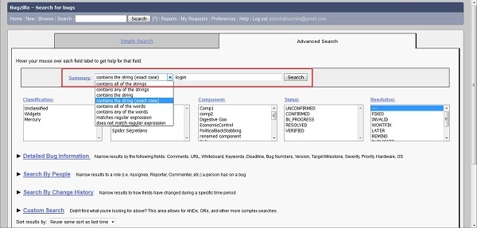
5. Observation
By using the search and filter features in Bugzilla, I can find defects that I have reported and check their current status. This makes it easier to identify bugs that are still being investigated, fixed or tested. It also helps me keep track of unresolved defects without manually checking every bug report.
Conclusion
In this task, I learned how to use Bugzilla's search and filter features to find defects reported by me that are not yet closed. I understood how to filter bugs using the reporter's user ID and defect status. This activity helped me understand how testers can monitor pending defects, track their progress and manage bug reports more efficiently.

